Live section!
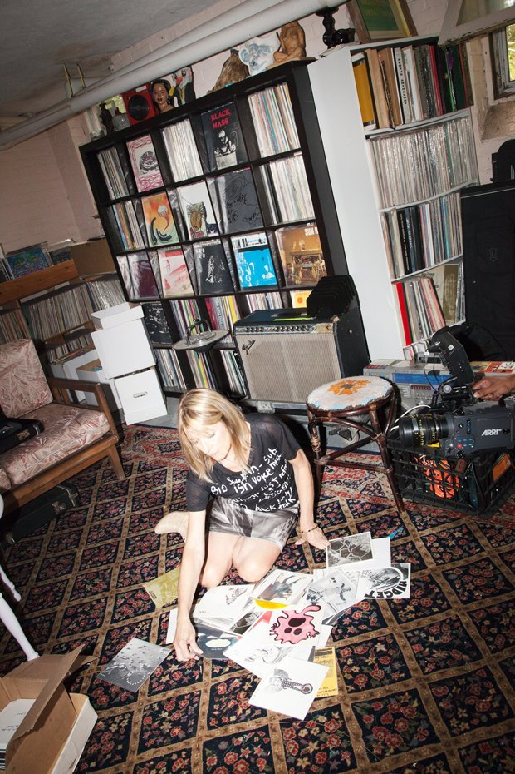
This section will be entirely dedicated to literature.
I will be posting some pictures, like this:

So here we are, in the world borne by something.

